DHAKA CITY OPEN GL PROJECT

Table of Contents
content | page
introduction | 1
Project graph | 2
function tables | 3-4
conclusion | 4

Introduction
Objects : Cars, truck , road , windmill , trees , building ,billboard ,street light ,clouds ,hot air balloon , metro rail , metro line
Animations: cloud , windmill
Mouse Interaction : Metro rail start, metro rail stop
Keyboard Interaction: Upper lane cars start/stop , Lower lane cars start/stop , Hot Air baloons start/stop
This project shows a simple city scene with many objects like cars, trucks, roads, windmills, trees, buildings, billboards, street lights, clouds, hot air balloons, and a metro rail with its line. Some objects are animated, like moving clouds and a rotating windmill. You can control parts of the scene using inputs. With the mouse, you can start or stop the metro rail. With the keyboard, you can start or stop cars on both upper and lower roads, and also control the hot air balloons.
I have added these Interaction features :
Key | Feature
a | Start Upper Lane Car
s | Stop Upper Lane Car
d | Start Lower Lane Car
f | Stop Lower Lane Car
g | Start baloon
h | Stop baloon
RMB | Start Metro Rail
LMB | Stop Metro Rail

*Project Graph
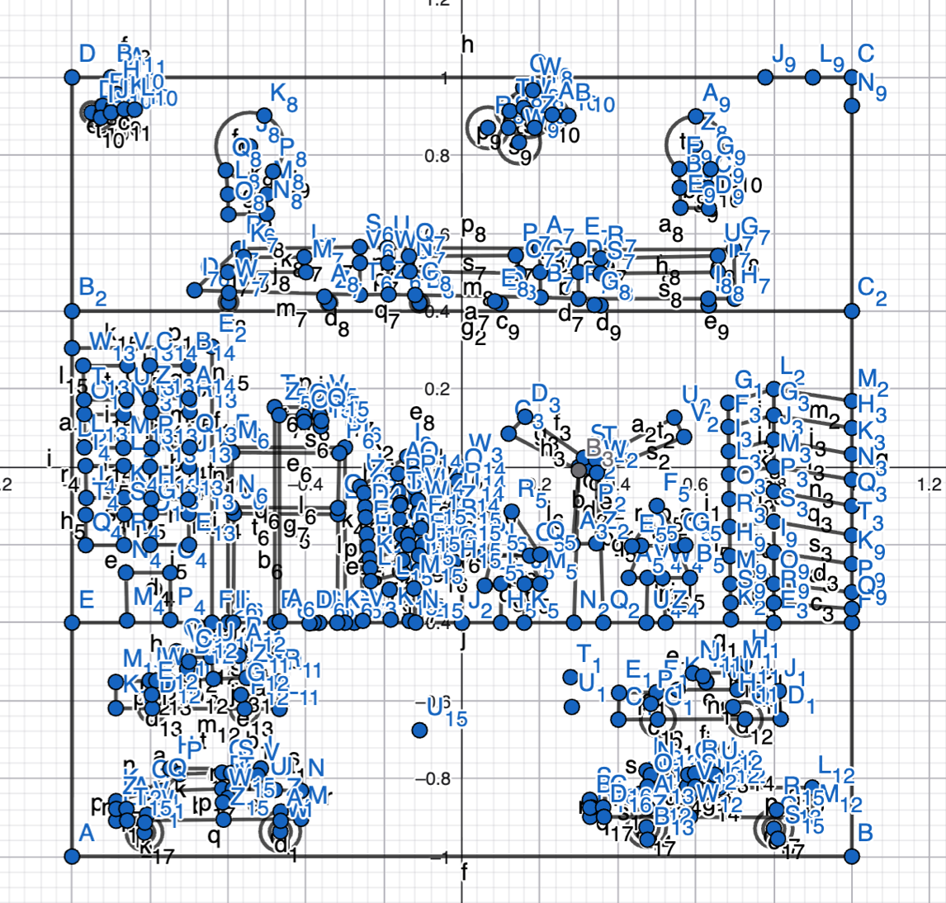
Figure : geogebra plotting
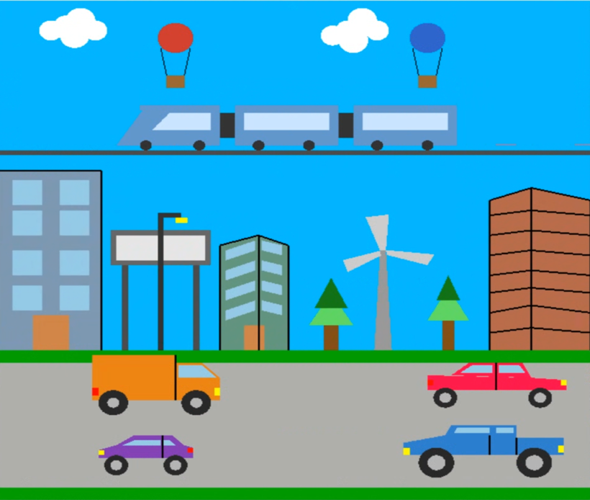

*List of objects assigning an object ID
SL# | Object Name | Object ID
1 | Purple Car | carLD1
2 | Truck | carLU1
3 | blue car | carRD1
4 | red car | carRU1
5 | Road | road1
6 | Windmill | drawBase1
7 | Windmill Blades | drawBlades1
8 | Left Tree | treeLeft1
9 | Right Tree | treeRight1
10 | Right Building | buildingRight1
11 | Left Building | buildingLeft1
12 | Billboard | billboard1
13 | Street Light | streetLight1
14 | middle building | buildingR1
15 | Clouds | clouds1
16 | Hot Air Balloons | hotAirBalloons1
17 | Metro Rail | metroRail1
18 | Metro Line | metroline1

*List of Functions To Represent Objects
SL# | Function Name | Object_ID
1 | carLD() | carLD1
2 | carLU() | carLU1
3 | carRD() | carRD1
4 | carRU() | carRU1
5 | road() | road1
6 | drawBase() | drawBase1
7 | drawBlades() | drawBlades1
8 | treeLeft() | treeLeft1
9 | treeRight() | treeRight1
10 | buildingRight() | buildingRight1
11 | buildingLeft() | buildingLeft1
12 | billboard() | billboard1
13 | streetLight() | streetLight1
14 | buildingR() | buildingR1
15 | clouds() | clouds1
16 | hotAirBalloons() | hotAirBalloons1
17 | metroRail() | metroRail1
18 | metroline() | metroline1

*List of Animation Functions with ID
SL# | Animation Function | Animation Function ID
1 | display() | display1
2 | update() | update1
3 | handleKeypress() | Keypress
4 | handleMouse() | Mouse

*Contribution
Member Name | Implemented Functions | Implemented Animation Functions | Percentage of Contribution
Tamzid Islam | ALL | ALL | 100%

Conclusion
This OpenGL project presents a scenario of a typical day in Dhaka city. I have implemented the concepts I learned in computer graphics to build this project. I used translation to move objects by continuously updating their positions to create animation. I also applied rotation to animate the windmill blades and car wheels. In addition, I used keyboard and mouse inputs to make the system interactive. The code is organized into separate functions, making it easy to understand, modify, and maintain. This project helped me gain practical experience in animation, transformations, and user interaction. In the future, I can improve it further by adding better visuals, smoother animations, and more realistic effects.

